**ANDROID MOBILE APPLICATION USER MANUAL**

**COMPLAINT ANDROID FORM**

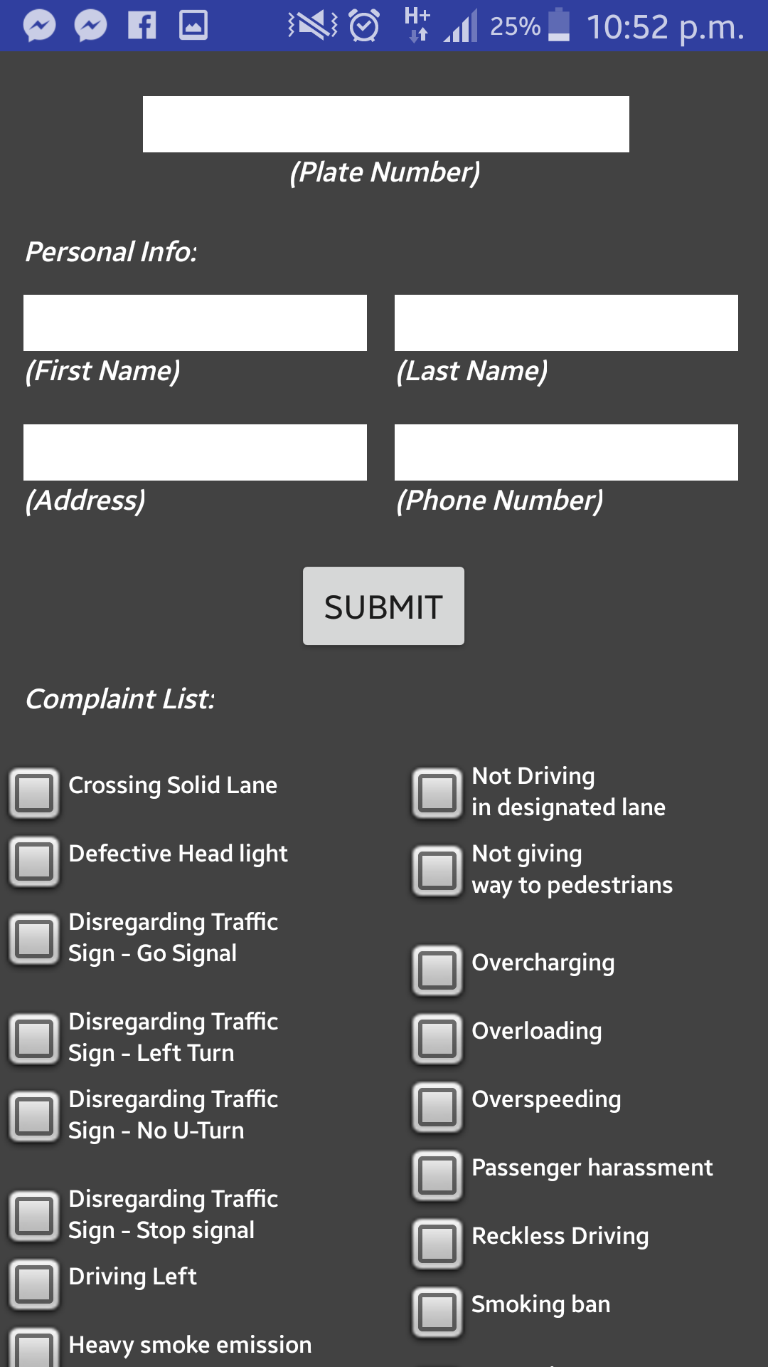

6

7

5

4

3

1

2

1. Input plate number of public vehicle
2. Input user first name
3. Input user last name
4. Input user address
5. Input user contact number
6. Select violation(s)
7. Tap to submit complaint

**COMPLAINT FORM: OTHER COMPLAINTS**

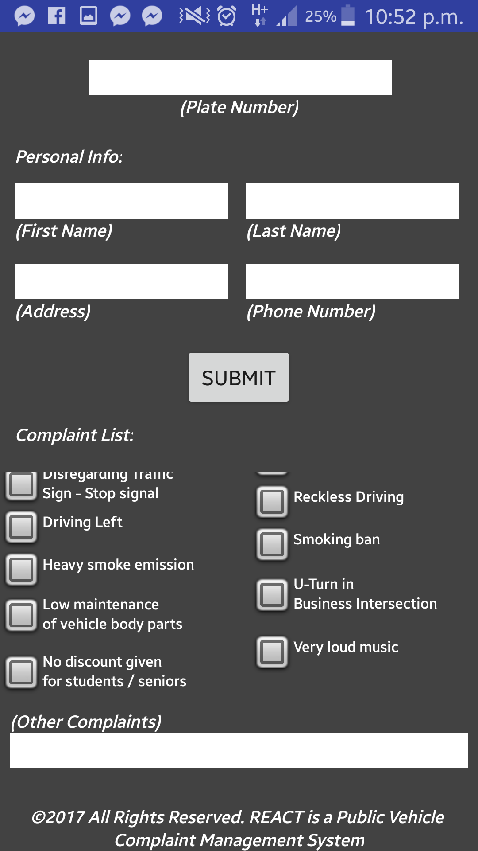

1

1. Input other complaint if complaint is unspecified in complaint list.